
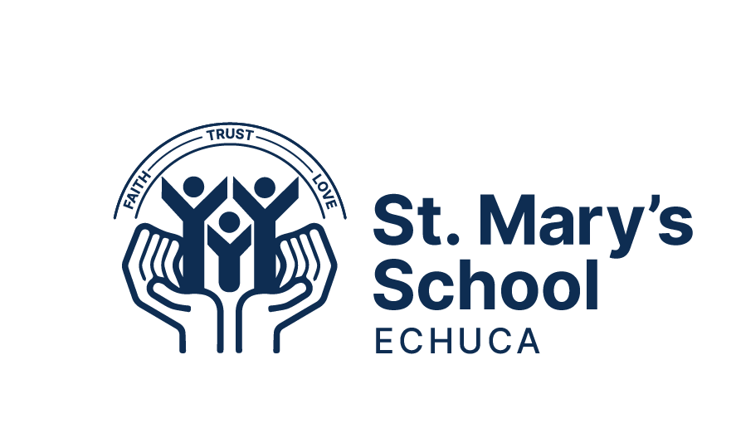

SCHEDULE OF FEES 2026
A faith community, learning together, spreading the Good News of Jesus through positive relationships, trust and love.

November 2025
Dear Parents and Carers,
Everyone in our school community works together to ensure all Learners at St Mary’s, get the best possible opportunities in their education. Part of this is to make sure the school has the resources to meet our learner’s needs. We all have a responsibility and a role to play in ensuring the ongoing management of the school's resources and it is for this reason that I am writing to you today.
Catholic schools operate on approximately 80% of the funding of what the state schools receive from the Government. Even with fewer resources from State and Federal Governments, the Catholic system is amongst the best in the world. Through school fees parents help to reduce the gap from 20% to around 10%. Even though it may not seem like much individually, when all families contribute to the financial needs of the school via fees it makes a huge difference to the opportunities children at St Mary’s can receive.
Please take your time to view our fee structure and plan how you can meet this in a way that suits you and your families other commitments.
If you hold a Health Care / Pensioner concession card, you are eligible to access CSEF assistance, which contributes to your child’s camps, sports, and excursions. This allowance is paid directly to the school and deducted from your fees. A form to apply for CSEF is attached. Catholic Education Sandhurst Ltd (CESL) is further supporting families holding a valid Health Care Card (HCC), as you are also eligible for a significant reduction in school fees, including all fees and levies. A copy of your valid HCC must be provided to the school along with the completion and commitment to a direct debit, and the fee relief will be automatically applied. Centrepay is also another supportive option, as fees are paid directly to the school from payments received from Family Tax A and B. If this option interests you, please request a form from the school office.

St. Mary’s and CESL Sandhurst expected payment of fees as of 2026 is Direct Debit. The school directly debits a specified amount from your bank account on a Friday and can be set up for weekly, fortnightly, monthly, quarterly or annual installments. A direct debiting authorisation form has been attached. Any alternate payment method must be discussed and approved by the Principal.
It is the school's belief that no child will be denied an opportunity to attend St Mary’s Echuca due to financial hardship. As Principal of St Mary’s I am always available to meet parents to discuss any hardships around paying school fees. There is an opportunity to apply for financial assistance from the school to help alleviate any issues around school fees if the need occurs. Our school fee policy and procedures can be found on St Mary’s website and on our parent management platform if you need to refer to it at any time.

On accepting and committing to enrolment within St Mary’s, Catholic Education Sandhurst Pty Ltd, parents / carers agree to paying fees. In respecting the dignity of all in our community it is expected that all families make the best effort to contribute to school fees.
Attached is St Mary's school fee and levy structure for 2026 - as a reference. Schools in Catholic Education are advised to increase fees annually in accordance with the Educational Consumer Price Index. Our school fees and levies ensure St Mary's can cover daily running costs as well as educational resources for our Learners.
If you have any queries pertaining to fees, please feel free to contact me.

Kind Regards

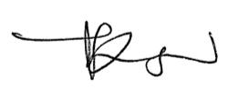
Jasmine Ryan

SCHOOL FEES & LEVIES 2026
Fees/Levies | 1 Child | 2 Children | 3 Children
Family School Fee | $1,470 | $1,781 | $2,050
Learning Levy (per child) | $535 | $1,070 | $1,605
Learning Experiences (per child) | $160 | $320 | $480
ICT Levy | $80 | $160 | $240
Capital & Maintenance Levy | $260 one payment per family
TOTAL | $2,505 | $3,591 | $4,635
Per Week (40 wks) | $63 | $90 | $116
Per Term | $627 | $898 | $1,159

Students in Years 3 - 6 attend camp, please add this to your fee total if you have a child in Year 3 - 6.
Camp Fees | 1 Child
Year Three (1 day) - Murray Life Adventures | $100
Year Four (1 day / 1 overnight) - Billabong Ranch | $250
Year Five (3 days / 2 overnight) - Log Cabin Camp Creswick | $375
Year Six (5 days / 4 overnight) - Canberra | $500

FEES / LEVY DESCRIPTIONS
Family School Fee | The Family School fee is a one off family fee that contributes to the daily operational costs of the school Eg: insurance, utilities. This is paid once per family regardless of the number of children who attend.
Learning Levy | The Learning Levy covers costs for classroom and stationary supplies, a contribution to ICT Leases and maintenance as well as Specialists Curriculum resources and activities.
Learning Experience Levy | The Learning Experience Levy covers all extracurricular learning experiences such as; excursions, incursions and sporting commitments.
ICT Levy | The ICT Levy contributes to the leasing of devices, subscriptions and multimedia resources and facilities that are used to engage and enhance learning and teaching throughout the school.
Capital / Maintenance  Levy | The Capital / Maintenance Levy covers regular school yard and building maintenance and improvement. It covers the care of the grounds and basic upkeep of buildings and facilities.

Direct Debit is our preferred method of payment. You can choose to pay weekly /fortnightly /monthly / quarterly /annually. Direct Debit Forms are available to print via Compass or collect from the office.

CAMP, SPORTS, EXCURSION FUND (CSEF)
Parents who hold a valid means-tested concession card may be entitled to receive the Victorian Government CSEF to offset the cost of any camp, sport activity or excursion. The eligibility date is first day of Term 1, January 27 2026 or the first day of Term 2, April 20, 2026. The amount for primary school aged children is $400 per student.

The CSEF is paid directly to the school and the amount is directly credited against the Camp, Sport and Excursion levy.

Application forms for the CSEF are available from the office or by clicking the CSEF link. If you received payment of the CSEF last year, you do not need to complete a new application for 2026, the school will resubmit an application on your behalf.

Please note, the School Savings Bonus has not been continued by the Victorian Government, but CSEF has increased from $154 to $400. CSEF applications close 4 July 2026.

Further information about this funding can be found at:

https://www.vic.gov.au/camps-sports-and-excursionsfund.

SPLIT BILLING OF SCHOOL FEES & LEVIES
If more than one person is responsible for the payment of school fees and levies an option to split the bill is available. In this case, each payer will receive a separate account for their portion only. Both parties must agree in writing before split billing can be implemented.
Split Billing Authority form can be collected from the school office.

2026 DIRECT DEBIT PROCESSING DATES
A number of payment methods are available, giving families the opportunity to select the most suitable option. Families are required to complete a 2026 Fee & Levy Payment Agreement, indicating their preferred payment method and frequency and return it to the office or by email fees@smechuca.catholic.edu.au before Friday December 5, 2025.

Weekly | Starting Friday 30th January
Fortnightly | Starting Friday 30th January
Monthly | Monday 16th February  Monday 16th March  Thursday 16th April  Monday 18th May  Tuesday 16th June  Thursday 16th July  Monday 17th August  Wednesday 16th September  Friday 16th October  Monday 16th November  Wednesday 16th December
Quarterly | Friday 30th January  Friday 24th April  Friday 17th July  Friday 9th October
Annually | Friday 3rd April

